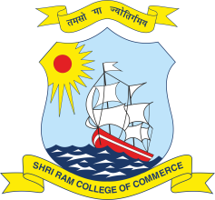 | SHRI RAM COLLEGE OF COMMERCE  University of Delhi, Maurice Nagar, Delhi – 110 007  Website: www.srcc.edu Phone: 27667905, 27666519

Date: 05.08.2020

STUDENTS NOTICE

With respect to Open Book Examinations (OBE) beginning from August 10, 2020 in On-line mode, the College Computer Lab shall be providing computer and internet facilities to limited students who wish to avail the College facilities, within College premises.

In case any student wish to avail the College Computer Center facilities for taking OBE, he/she must send willingness on the following email ID latest by Friday, 7th August, 2020, 5.00 pm.

computer.centre10@srcc.du.ac.in

While sending willingness the student should mention his/her Name, Class, Section, College Roll No., University Examination Roll No., Mobile Number, E mail ID, and date(s) on which he/she wish to come for taking OBE.

The subject of the email should be Request for College Computer Center facilities for OBE.

PRINCIPAL

